|  |  |  |  |
| --- | --- | --- | --- |
|  | name | Edu mail | B.N |
| 1 | كيرلس جاملان ادولف | Kirless180553@feng.bu.edu.eg | 1141 |

Title: -

Programming Languages

ـــــــــــــــــــــــــــــــــــــــــــــــــــــــــــــــــــــــــــــــــــــــــــــــــــــــــــــــــــــــــــــــــــــــــــــ

Abstract

A computer programming language is a language used to write computer programs, involving a machine running some form of computation or algorithm and possibly controlling external devices such as printers, disk drives, robots and so on. For example, PostScript programs are sometimes generated for the control of a computer printer or display by another program. More generally, a programming language on any, possibly abstract, computer may define computation. It is widely agreed that a full programming language specification comprises a description, possibly idealized, of a computer or processor for that language.

In most practical contexts, a programming language involves a computer; consequently, programming languages are usually defined and studied this way. Programming languages differ from natural languages in that natural languages are only used for interaction between people, while programming languages also allow humans to communicate instructions to machines.

Programming languages typically contain abstractions to describe and manipulate data structures, or to monitor the execution flow. The functional importance of a programming language supporting sufficient abstractions is demonstrated by the concept of abstraction. This theory is often articulated as a suggestion to the programmer to use such abstractions properly.

Screenshots

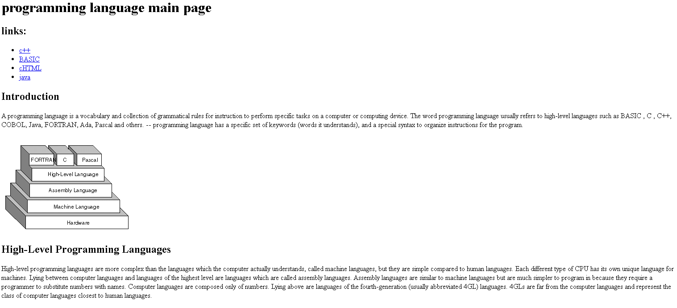

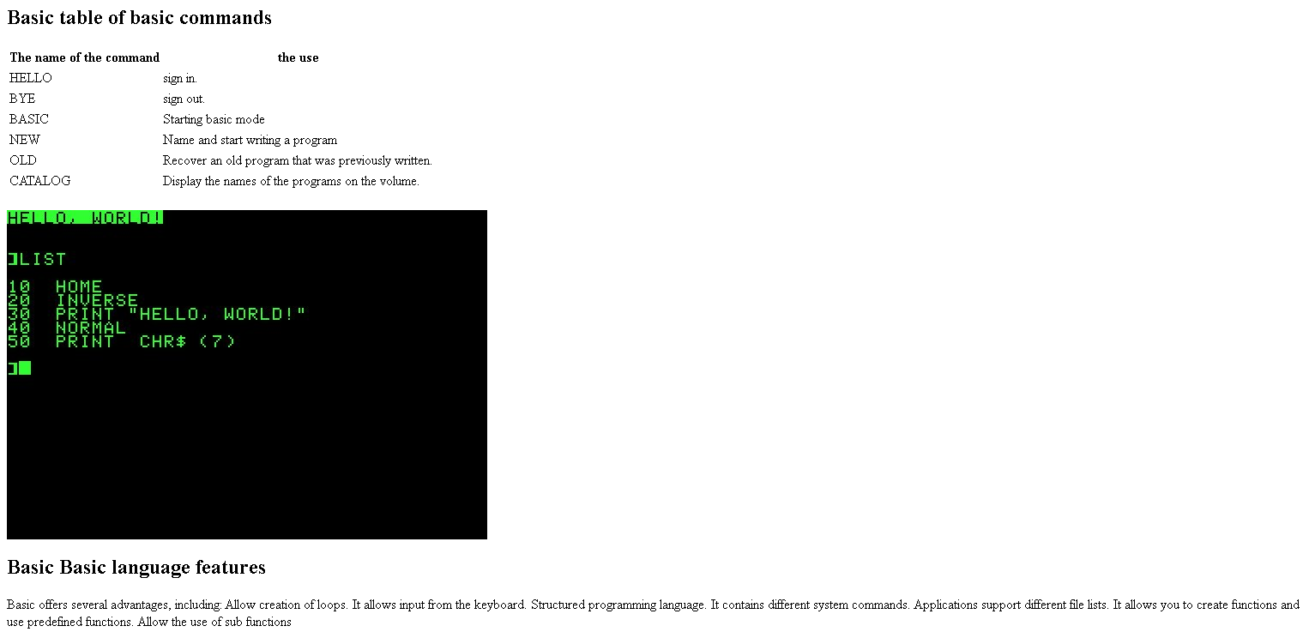

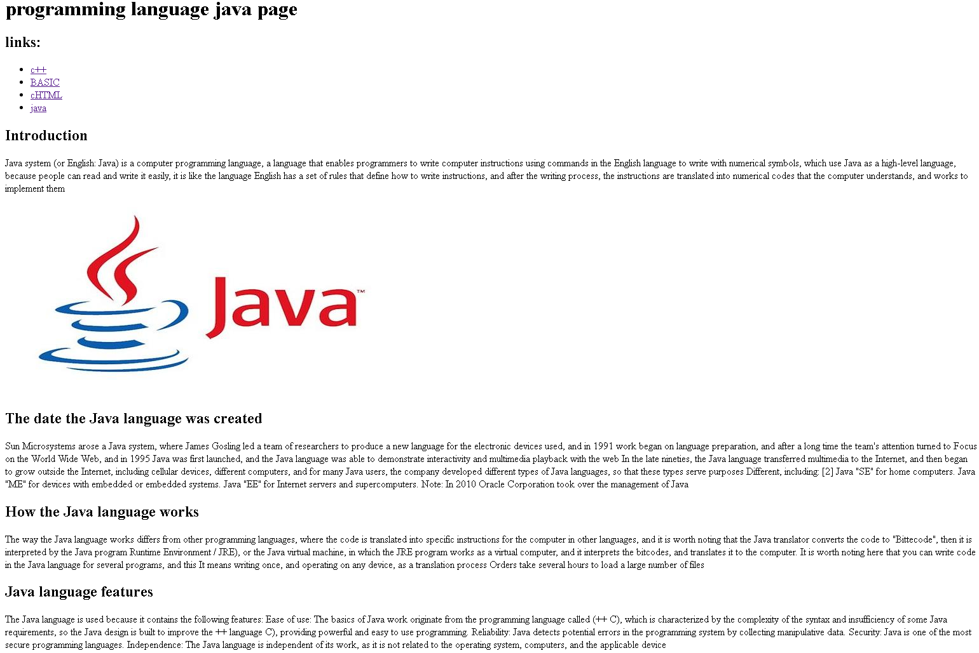

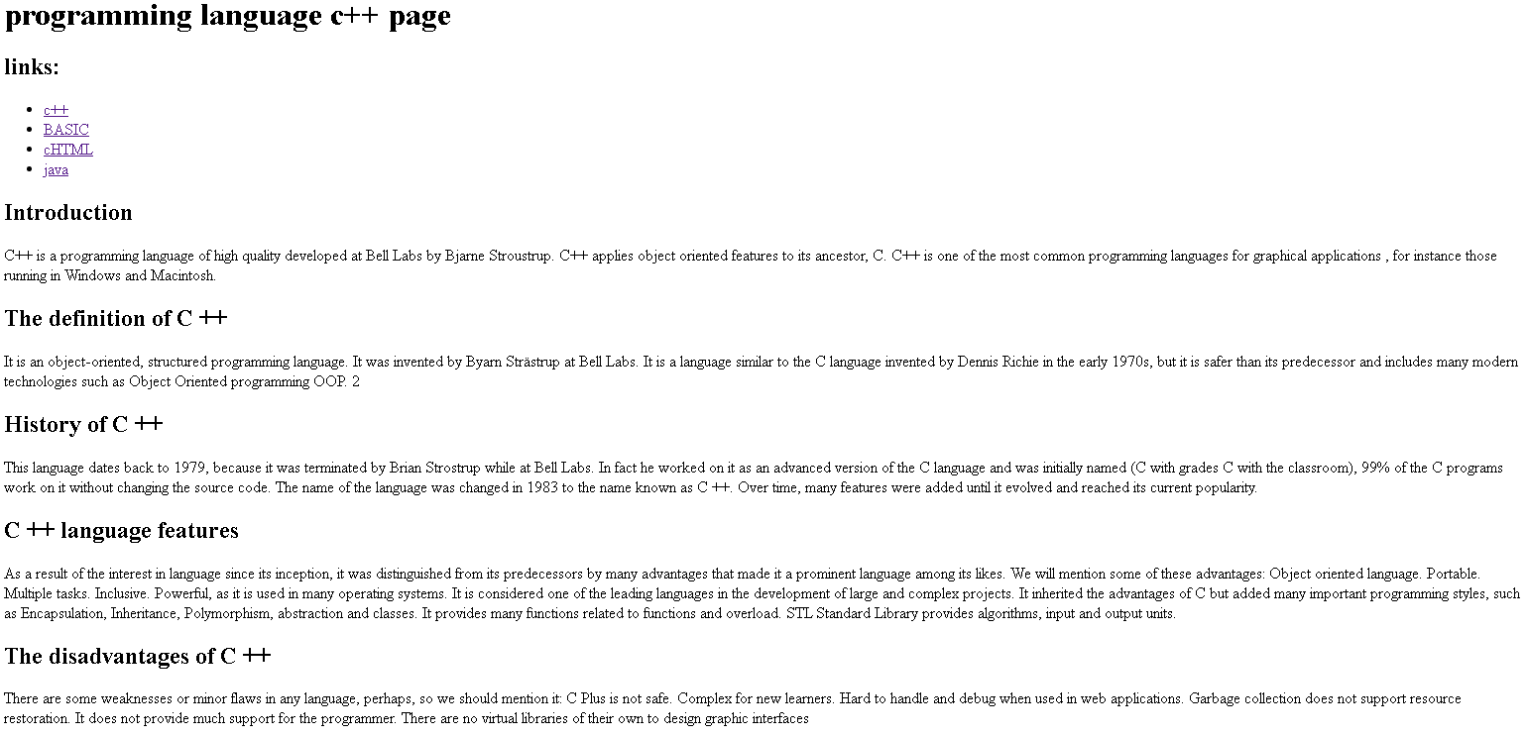

Source code:

